**ServiceNow Administration**

**Project Documentation**

**Project Title – Educational Organization Using ServiceNow**

**Problem Statement**

Educational institutions face challenges in managing student admissions, parent communication, and tracking academic progress. Manual systems result in delays, errors, and inefficiencies, especially in capturing, maintaining, and analyzing student data.

This project aims to provide a complete digital solution using **ServiceNow**. Our system includes modules for student admission, student progress tracking, and parental contact information through custom forms and tables, with dynamic functionalities, calculated fields, and update sets for deployment.

**Problem Overview**  
The Educational Management System (EMS) is a streamlined solution built on the ServiceNow platform to enhance administrative efficiency within educational institutions. It manages student and teacher data, simplifies the admission process, and provides tools for tracking academic progress. By implementing EMS in ServiceNow, institutions benefit from a user-friendly, customizable, and automated environment that supports better decision-making and operational management.

**Implementation Workflow**

**1. Setting Up ServiceNow Instance**

* Logged into ServiceNow Developer site
* Requested personal developer instance
* Activated the instance and opened ServiceNow studio

**2. Create Local Update Set**

● **Purpose**: To track all changes made during the development of the **Educational Organisation Using ServiceNow**

1. Log in to your ServiceNow instance.

2. Navigate to:

All → Update Sets → Local Update Sets

3. Click New to create a new update set.

4. Fill in the following details:

○ Name: **Educational Organisation Using ServiceNow**

5. Click **Submit** and then click **Make Current** to activate the update set.

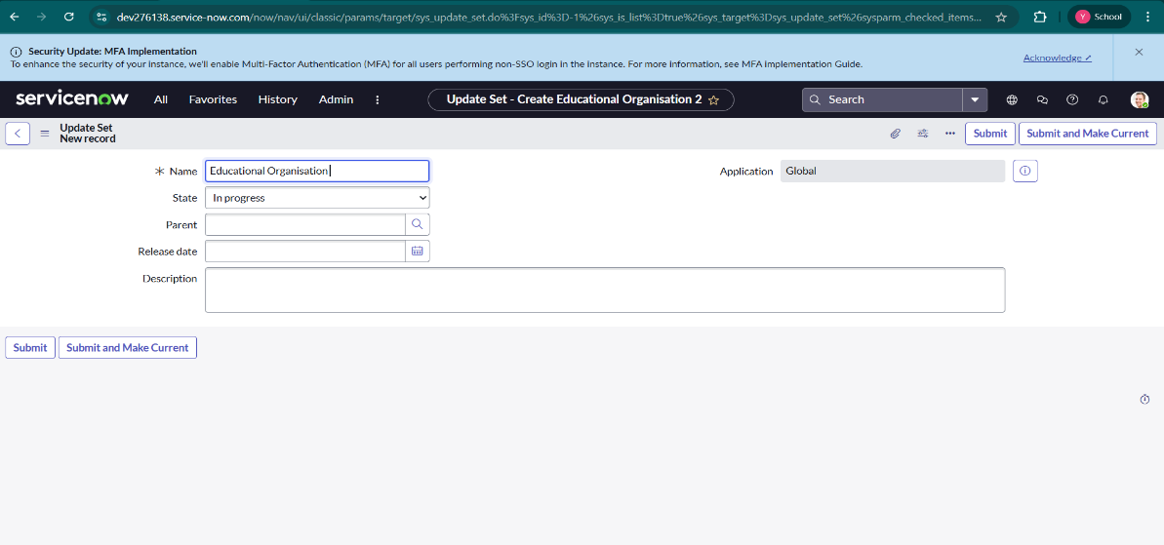

**3. Creating Tables**

* **Creating a SalesForce Table**
* All >> Tables.

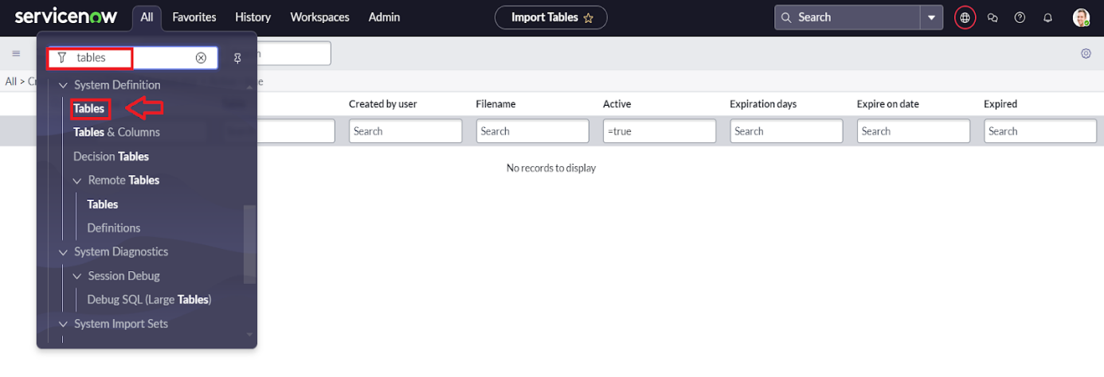

* Click on New

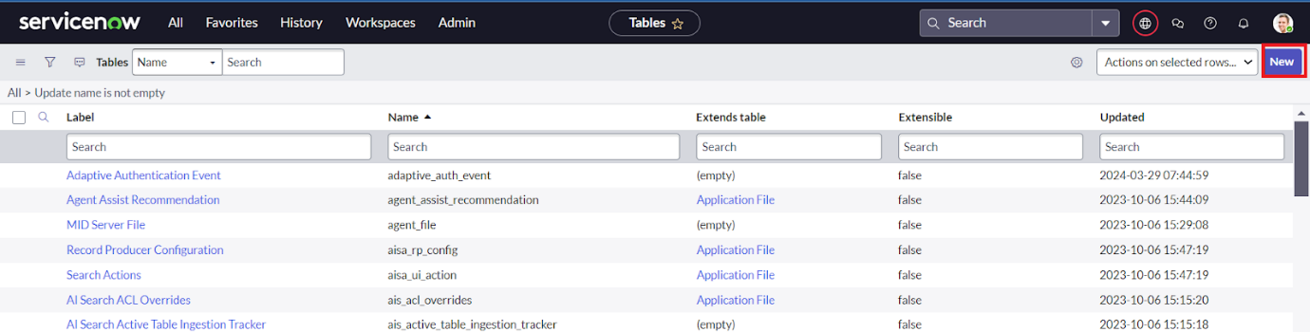

* Enter the Label: Salesforce >> Click on Name it will Automatically generate Api name.

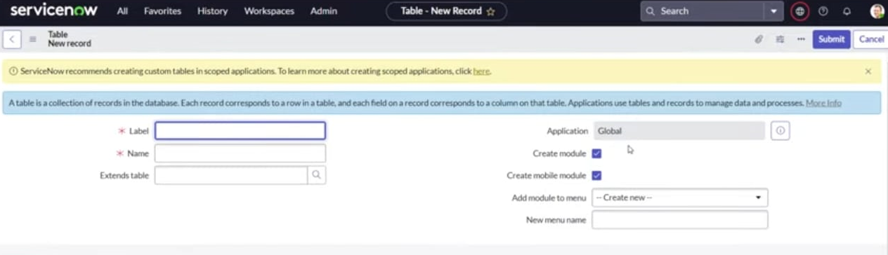

Create columns as given below, Double Click on Column label and Enter the Column labels and click on the tick mark >> Give Type as given .

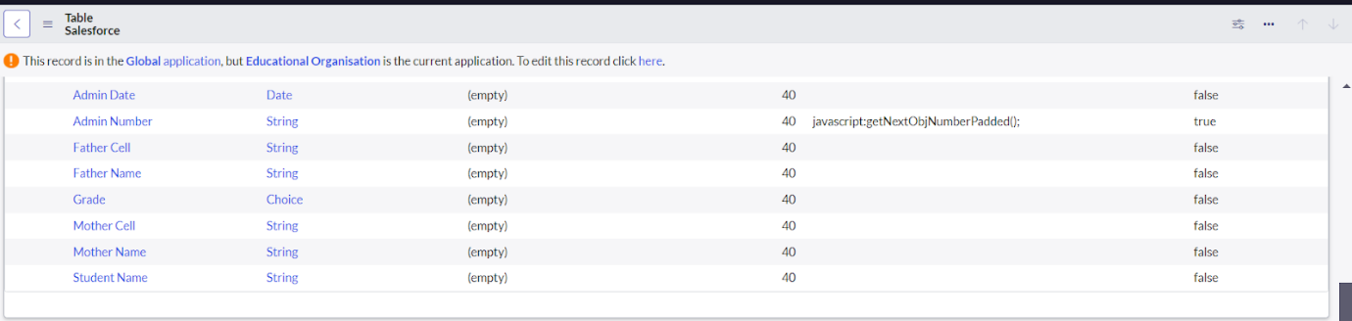

* For “Admin Number” Give Display as True and right click on the toggle bar on top >> save.

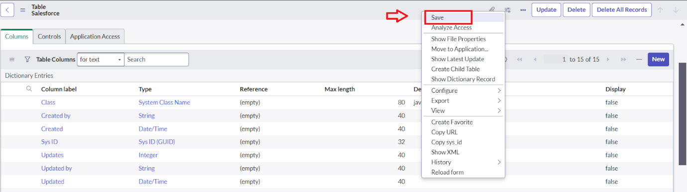

Click on controls >> Enable Extensible.

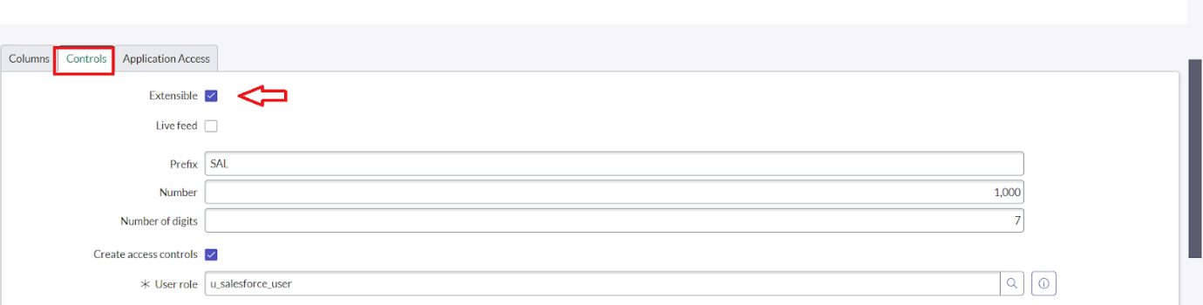

* Click on “Admin Number” column, In Related Links Click on Advanced View >> Default View (Enable Use dynamic default) >> select Get Next Padded Number in Dynamic default value >> Update .

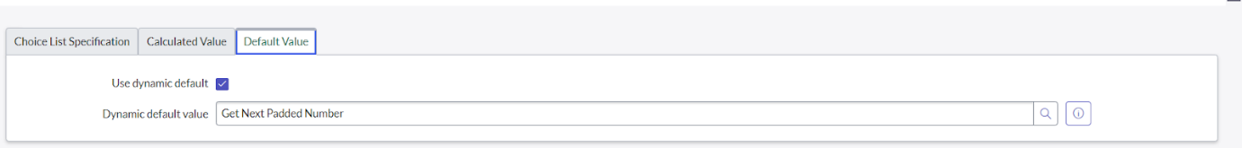

* Click on “Grade” Column >> Click on Choices and give Label,Value and Sequence as given below.

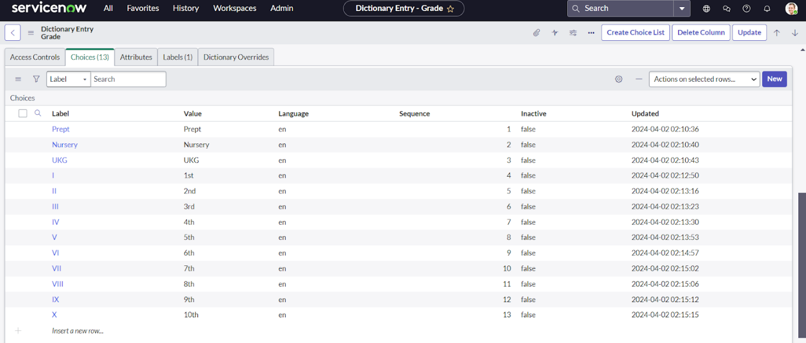

* Added necessary columns like Admission Number, Student Name, Grade, etc.
* **.Creating Admission Table**
* Create an Admission Table with Columns given.
* Select Extends Table >> Salesforce and also Select Add module to menu >> Salesforce.
* Create Fields as shown

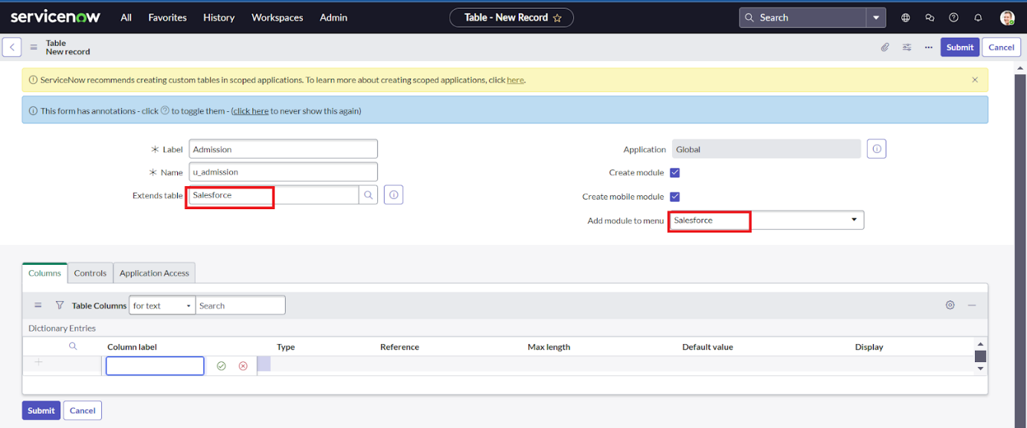

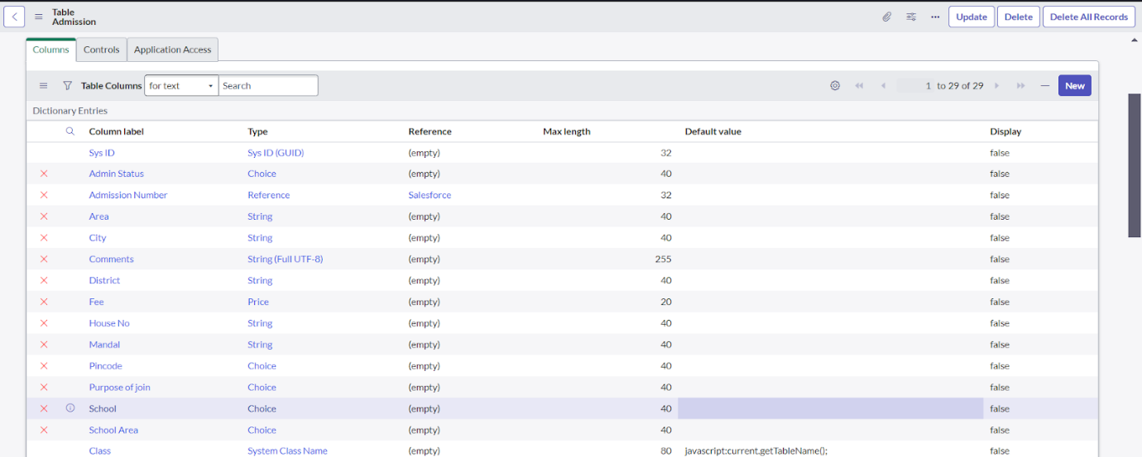

After That:

* Create choice for Admin Status as:

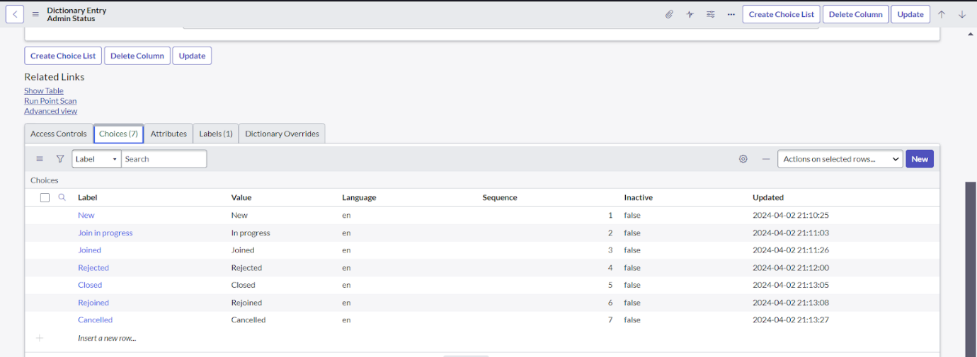

* Create choice for Pincode as:

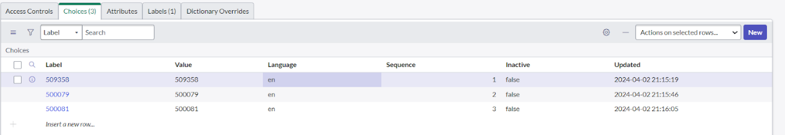

* Create choice for Purpose of Join as:

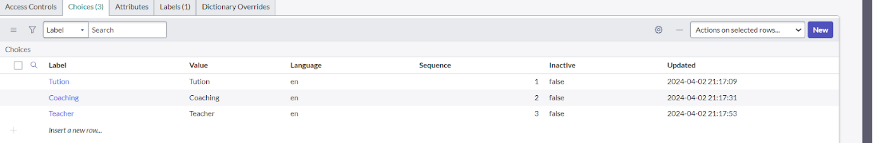

* Create choice for School as:

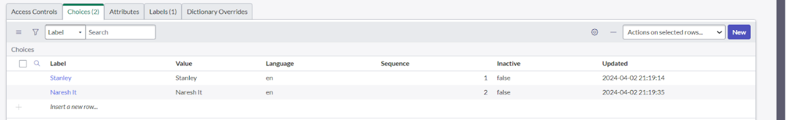

* Create choice for School Area as:

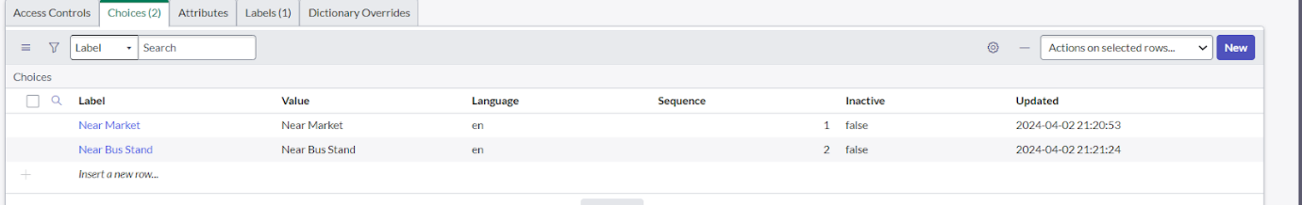

* **Creating Student Progress Table**
* Create a Student Progress Table with Columns given.
* Select Add module to menu >> Salesforce.
* Create Fields as shown:

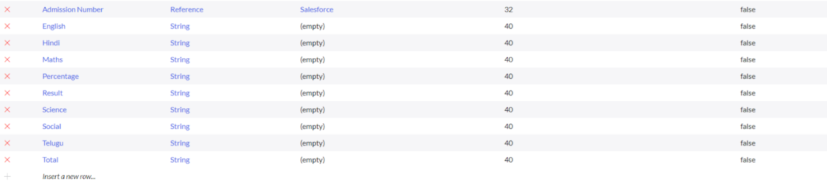

**4. Form Layout**

* Modified form sections for clarity
* **Configuring Table form for Student Progress Table**
* In the Student Progress Table Page, Click on Layout form .

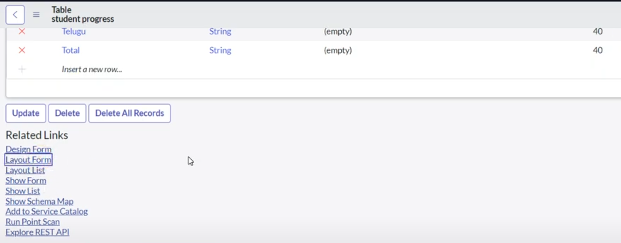

* Click on Admission Number [+] .

* 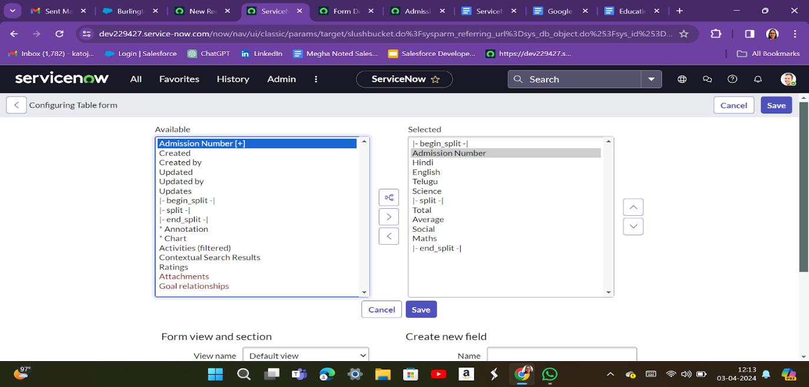
* Select below Admission Number fields in Available side and send it to selected side as below >> save.

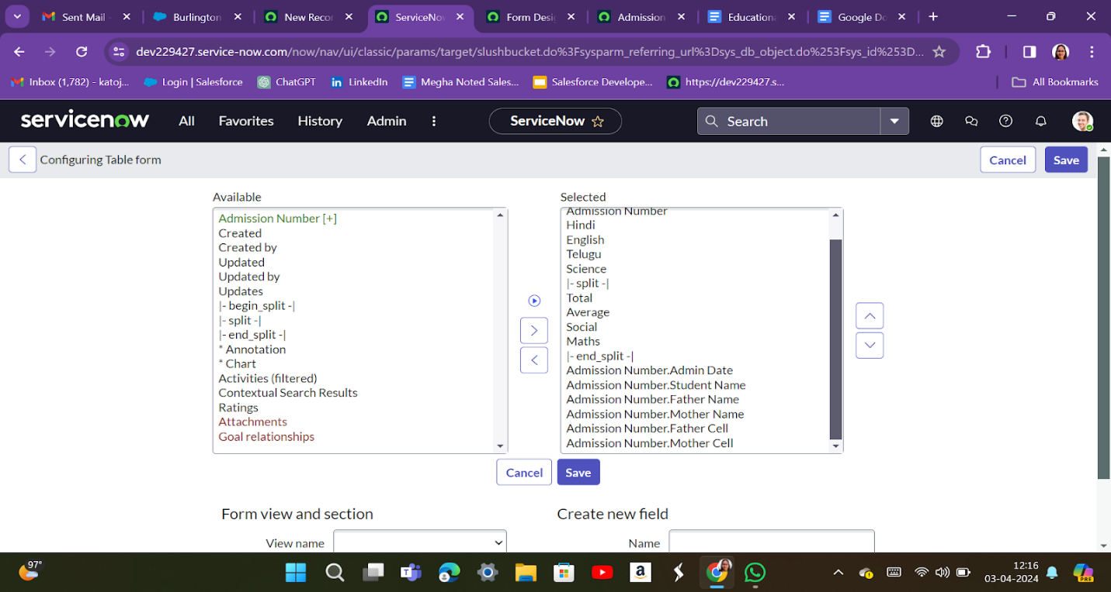

* Added tabs like **School Details** and **Address** under the Admission form

**5. Form Design**

**Creating Form Design for Salesforce Table**

1. All >> System Definition >> Tables .
2. In Label Search for Salesforce and open .

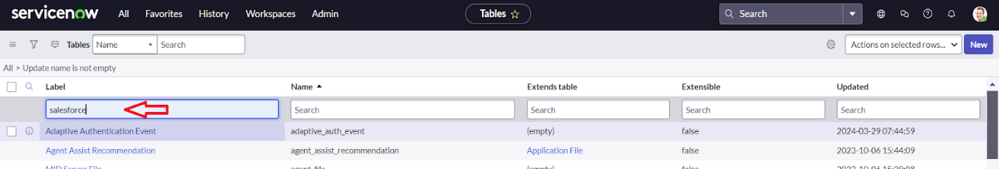

1. Right Click on top Toggle >> Configure >> Form Design.

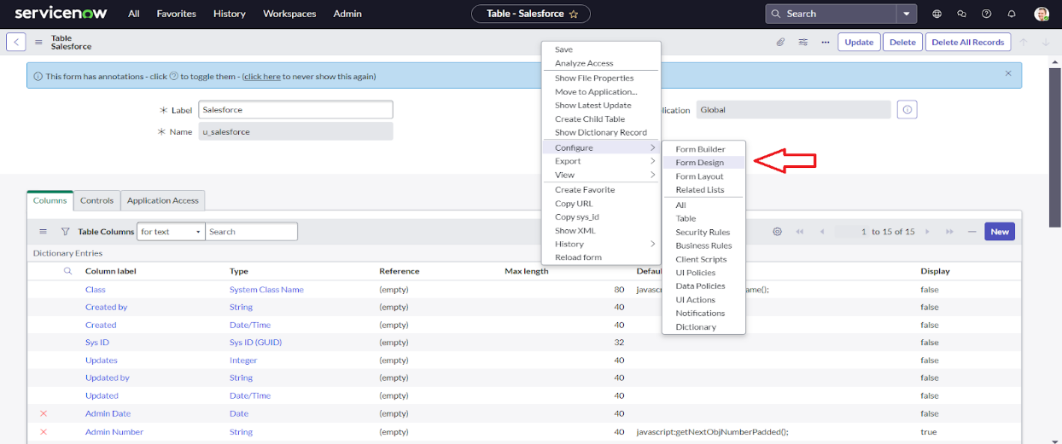

1. In drop down select Salesforce(u_salesforce).

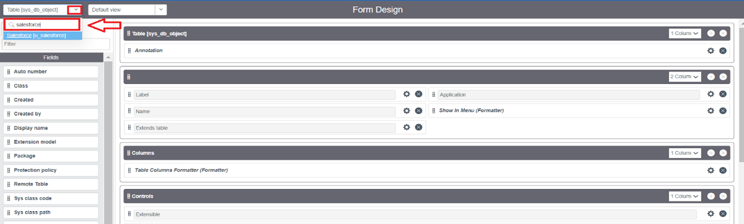

1. Drag and drop the fields to the left side as below.

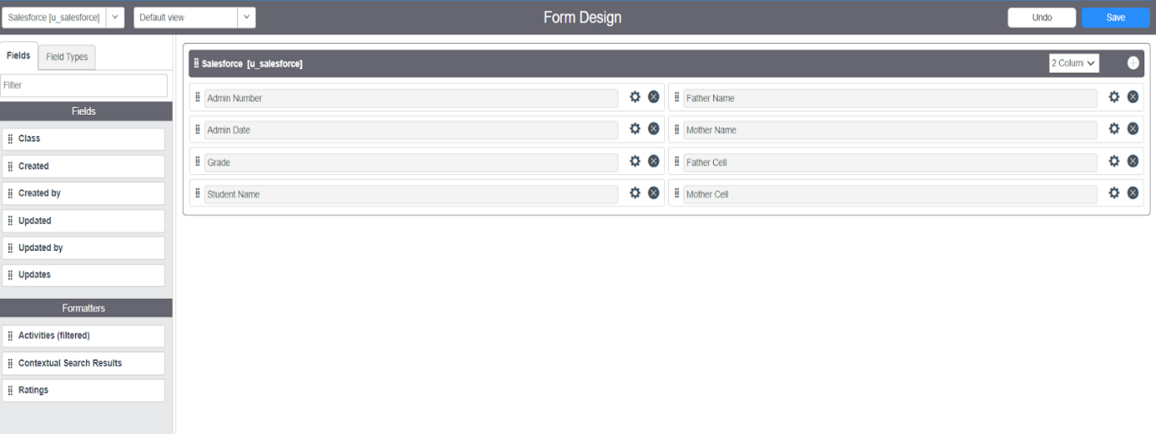

1. Save.

* **DO same for Admission Table and Student Progress Table As per our Project Requirements .You Can Organize in Form Design**

**6. Number Maintenance**

* **Creating Number Maintenance for Admin Number**
* All >> Number Maintenance >> New

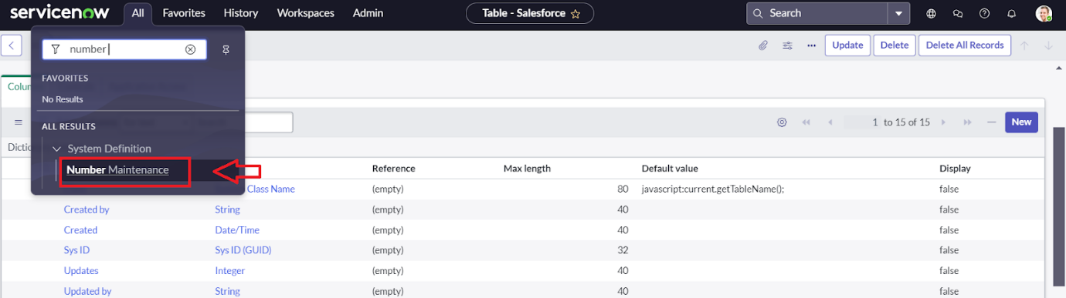

* Fill the details >> Submit.

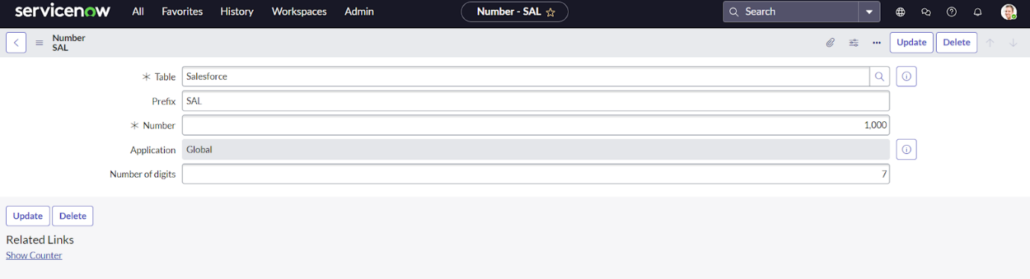

* Configured prefix SAL and a format for sequential IDs

**7. Process Flow**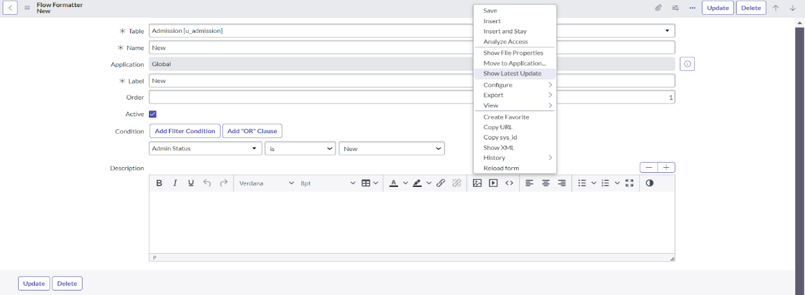

* Created a flow for admission status:
  + New → In Progress → Joined → Rejected → Rejoined → Closed → Cancelled
* Added business logic to transition between stages

**8. Client Script:**

* **Creating “Auto populate” Client Scripts for Admission Table**
* All >> Client Scripts >> New.
* Fill the Details as given.

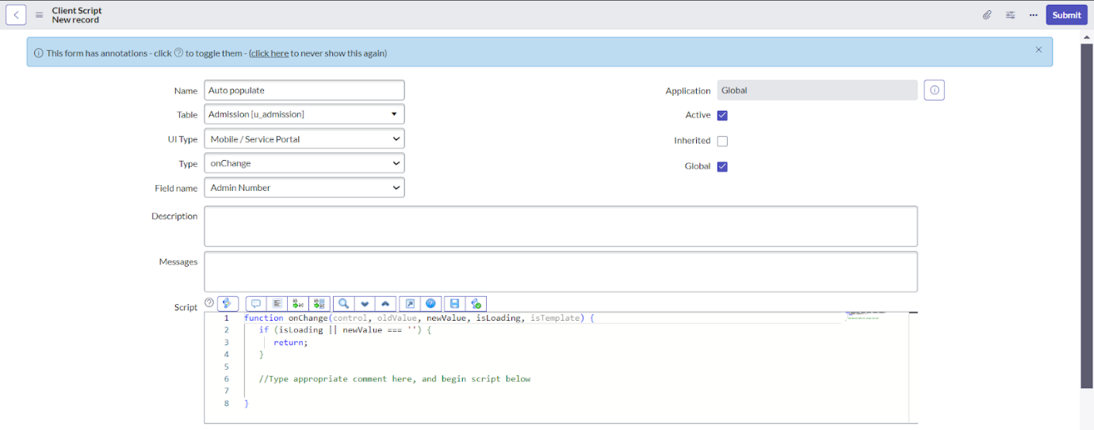

* Write the Code as below, Enable Isolate script and Save.

function onChange(control, oldValue, newValue, isLoading, isTemplate) {

   if (isLoading || newValue === '') {

      return;

   }

   //Type appropriate comment here, and begin script below

   var a = g_form.getReference('u_admission_number');

   g_form.setValue('u_admin_date',a.u_admin_date);

   g_form.setValue('u_grade',a.u_grade);

   g_form.setValue('u_student_name',a.u_student_name);

   g_form.setValue('u_father_name',a.u_father_name);

   g_form.setValue('u_mother_name',a.u_mother_name);

   g_form.setValue('u_father_cell',a.u_father_cell);

   g_form.setValue('u_mother_cell',a.u_mother_cell);

   g_form.setDisabled('u_admin_date',a.u_admin_date);

   g_form.setDisabled('u_grade',a.u_grade);

   g_form.setDisabled('u_student_name',a.u_student_name);

   g_form.setDisabled('u_father_name',a.u_father_name);

   g_form.setDisabled('u_mother_name',a.u_mother_name);

   g_form.setDisabled('u_father_cell',a.u_father_cell);

   g_form.setDisabled('u_mother_cell',a.u_mother_cell);

}

**Note: Make sure the Field names should be the same as you created .**

* **Creating “Pincode Update” Client Scripts for Admission Table**

Do As per the Auto Populate Instructions and dor this you have to change the js

* Write the Code as below, Enable Isolate script and Save.

function onChange(control, oldValue, newValue, isLoading, isTemplate) {

   if (isLoading || newValue === '') {

      return;

   }

    var a = g_form.getValue('u_pincode');

if(a == '509358')

{

g_form.setValue('u_mandal', 'kadthal');

g_form.setValue('u_city', 'kadthal');

g_form.setValue('u_district', 'RangaReddy');

}

else if(a == '500081')

{

g_form.setValue('u_mandal', 'karmanghat');

g_form.setValue('u_city', 'karmanghat');

g_form.setValue('u_district', 'RangaReddy');

}

else if(a == '500079')

{

g_form.setValue('u_mandal', 'Abids');

g_form.setValue('u_city', 'AsifNagar');

g_form.setValue('u_district', 'Hyderabad');

}

   //Type appropriate comment here, and begin script below

}

* **Creating “Disable Fields” Client Scripts for Admission Table**
* Write the Code as below, Enable Isolate script and Save.

function onLoad() {

   //Type appropriate comment here, and begin script below

   g_form.setDisabled('u_total',true);

   g_form.setDisabled('u_percentage',true);

   g_form.setDisabled('u_result',true);

}

* **Creating “Total Update” Client Scripts for Student progress Table**
* **Creating “Result” Client Scripts for Student progress Table**
* **Creating “Percentage” Client Scripts for Student progress Table**

**9. Result**

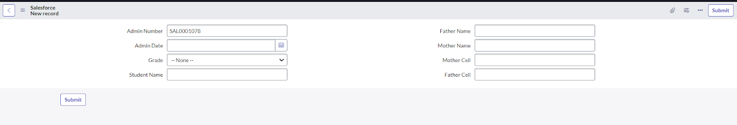

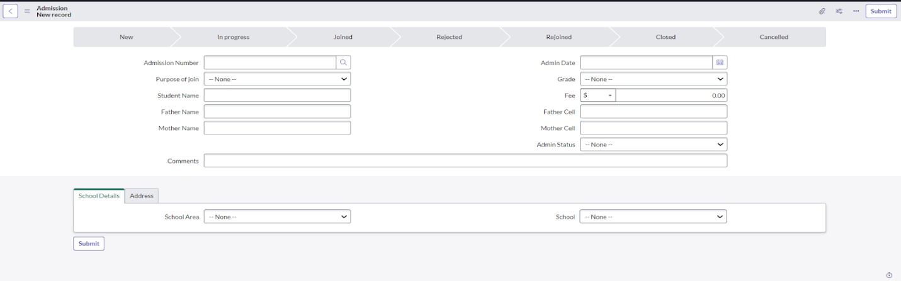

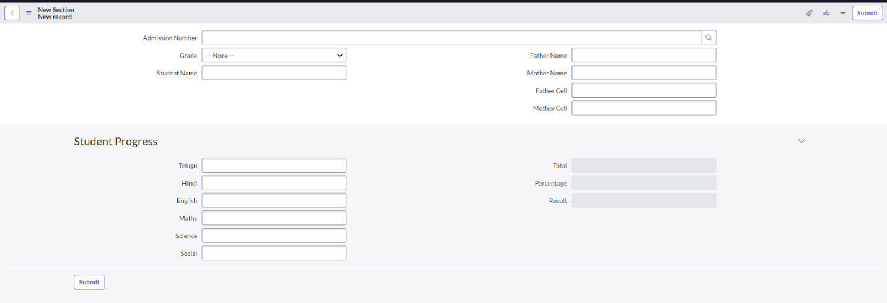

**Conclusion**

The Student Management System developed on ServiceNow digitizes the key workflows in an educational organization. It simplifies the admission process, ensures accurate student records, and automates progress tracking.